CSA5159-CNS For Infrastructure Security

1. Write a program for Caesar cipher involves replacing each letter of the alphabet with the letter
standing k places further down the alphabet, for k in the range 1 through 25.

#include <stdio.h>
#include <string.h>

int main()
{
char text[100];
int k, i;

printf("Enter plaintext: ");
scanf("%s", text);

printf("Enter key (1-25): ");
scanf("%d", &k);

printf("Ciphertext: ");

for(i = 0; text[i] != '\0'; i++)
{
char ch = text[i];

if(ch >= 'A' && ch <= 'Z')
ch = ((ch - 'A' + k) % 26) + 'A';

else if(ch >= 'a' && ch <= 'z')
ch = ((ch - 'a' + k) % 26) + 'a';

printf("%c", ch);
}

printf("\n");
return 0;
}
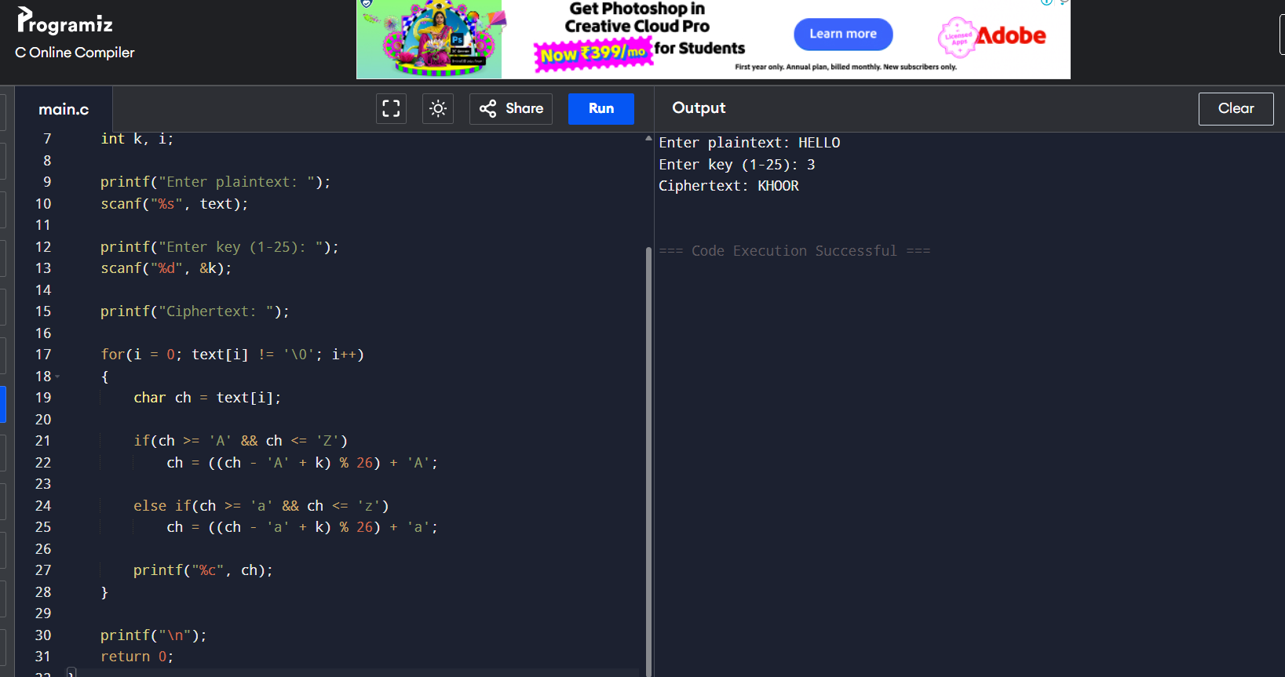

2. Write a program for monoalphabetic substitution cipher maps a plaintext alphabet to a ciphertext
alphabet, so that each letter of the plaintext alphabet maps to a single unique letter of the ciphertext
alphabet.

#include <stdio.h>
#include <string.h>
#include <ctype.h>

int main()
{
char plaintext[100], ciphertext[100];

// Substitution key
char key[] = "QWERTYUIOPASDFGHJKLZXCVBNM";

printf("Enter Plaintext: ");
scanf("%s", plaintext);

for(int i = 0; plaintext[i] != '\0'; i++)
{
char ch = toupper(plaintext[i]);

if(ch >= 'A' && ch <= 'Z')
ciphertext[i] = key[ch - 'A'];
else
ciphertext[i] = ch;
}

ciphertext[strlen(plaintext)] = '\0';

printf("Ciphertext: %s\n", ciphertext);

return 0;
}

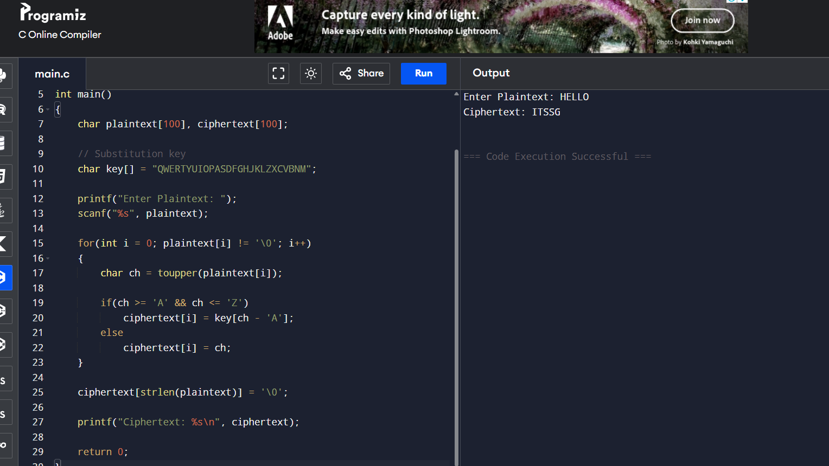
3. Write a C program for Playfair algorithm is based on the use of a 5 X 5 matrix of letters constructed
using a keyword. Plaintext is encrypted two letters at a time using this matrix.

#include <stdio.h>
#include <string.h>
#include <ctype.h>

char matrix[5][5];

// Function to generate Playfair matrix
void generateMatrix(char key[]) {
int used[26] = {0};
int row = 0, col = 0;

used['J' - 'A'] = 1; // I and J treated as same

for (int i = 0; key[i] != '\0'; i++) {
char ch = toupper(key[i]);

if (ch == 'J')
ch = 'I';

if (!used[ch - 'A']) {
matrix[row][col++] = ch;
used[ch - 'A'] = 1;

if (col == 5) {
row++;
col = 0;
}
}
}

for (char ch = 'A'; ch <= 'Z'; ch++) {
if (!used[ch - 'A']) {
matrix[row][col++] = ch;

if (col == 5) {
row++;
col = 0;
}
}
}
}

// Find position of character in matrix
void findPosition(char ch, int *row, int *col) {
if (ch == 'J')
ch = 'I';

for (int i = 0; i < 5; i++) {
for (int j = 0; j < 5; j++) {
if (matrix[i][j] == ch) {
*row = i;
*col = j;
return;
}
}
}
}

// Encrypt plaintext
void encrypt(char text[]) {
int len = strlen(text);

printf("\nEncrypted Text: ");

for (int i = 0; i < len; i += 2) {
char a = toupper(text[i]);
char b = toupper(text[i + 1]);

int r1, c1, r2, c2;

findPosition(a, &r1, &c1);
findPosition(b, &r2, &c2);

if (r1 == r2) {
printf("%c%c",
matrix[r1][(c1 + 1) % 5],
matrix[r2][(c2 + 1) % 5]);
}
else if (c1 == c2) {
printf("%c%c",
matrix[(r1 + 1) % 5][c1],
matrix[(r2 + 1) % 5][c2]);
}
else {
printf("%c%c",
matrix[r1][c2],
matrix[r2][c1]);
}
}
}

int main() {
char key[50], text[100];

printf("Enter Keyword: ");
scanf("%s", key);

printf("Enter Plaintext (even length): ");
scanf("%s", text);

generateMatrix(key);

printf("\nPlayfair Matrix:\n");
for (int i = 0; i < 5; i++) {
for (int j = 0; j < 5; j++)
printf("%c ", matrix[i][j]);
printf("\n");
}

encrypt(text);

return 0;
}

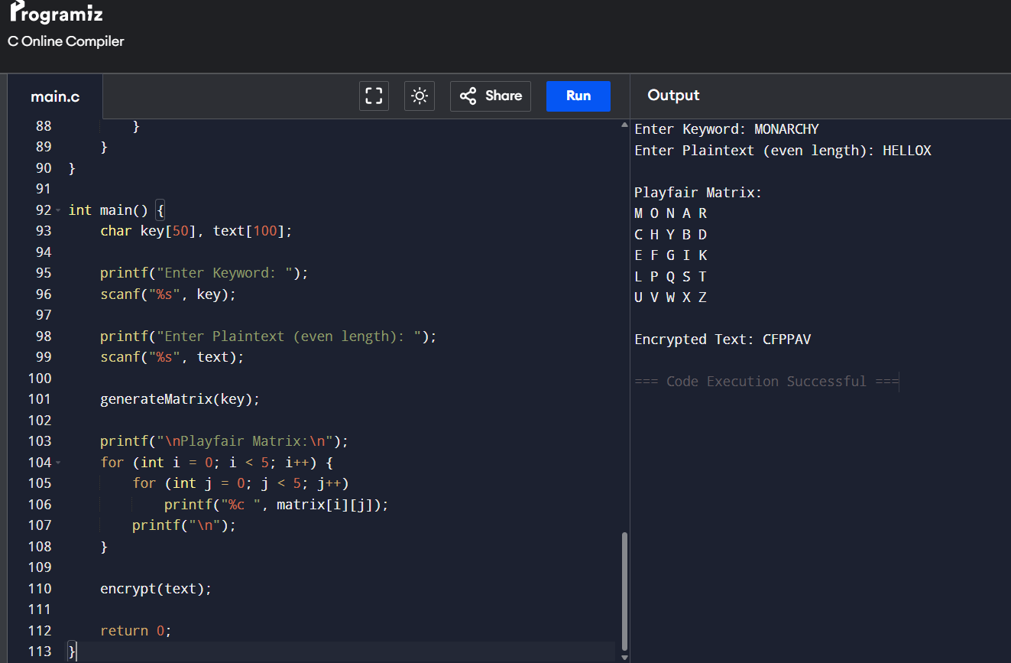

4. Write a C program for polyalphabetic substitution cipher uses a separate monoalphabetic substitution
cipher for each successive letter of plaintext, depending on a key.

#include <stdio.h>
#include <string.h>
#include <ctype.h>

int main() {
char text[100], key[100];
int i, j = 0;

printf("Enter Plaintext: ");
scanf("%s", text);

printf("Enter Key: ");
scanf("%s", key);

int keyLen = strlen(key);

printf("Ciphertext: ");

for(i = 0; text[i] != '\0'; i++) {
char p = toupper(text[i]);
char k = toupper(key[j % keyLen]);

char c = ((p - 'A') + (k - 'A')) % 26 + 'A';
printf("%c", c);

j++;
}

return 0;
}
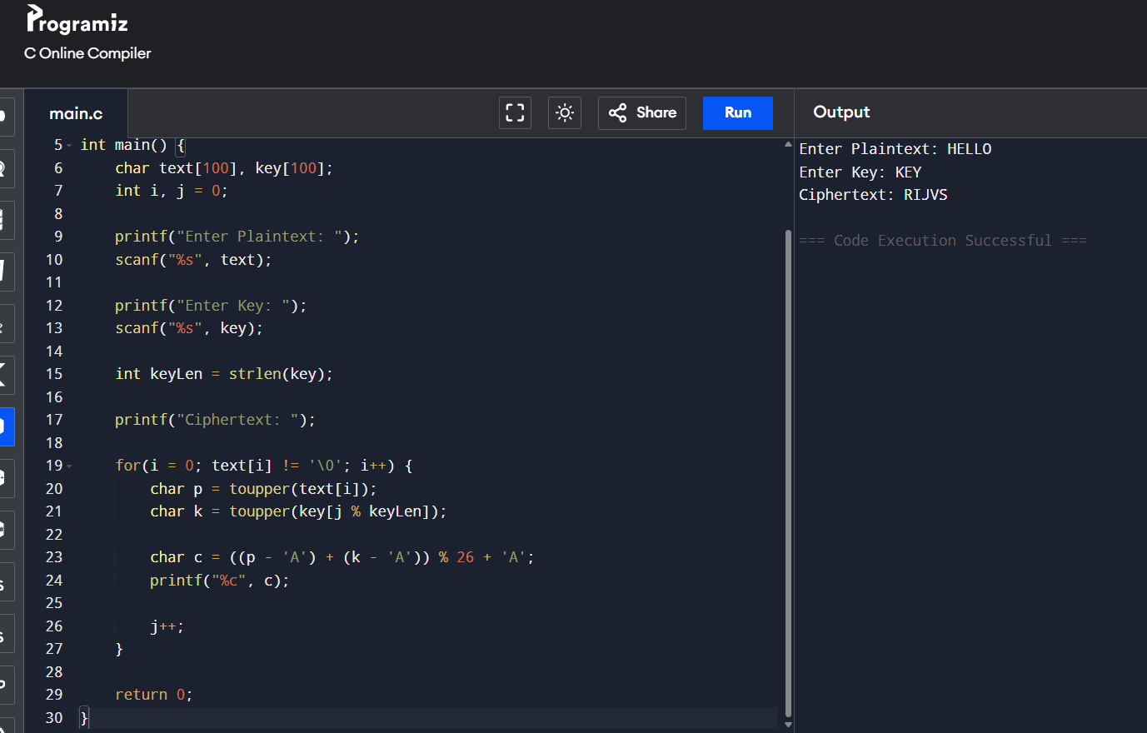

5. Write a C program for generalization of the Caesar cipher, known as the affine Caesar cipher, has the
following form: For each plaintext letter p, substitute the ciphertext letter C: C = E([a, b], p) = (ap + b)
mod 26 A basic requirement of any encryption algorithm is that it be one-to-one. That is, if p q, then
E(k, p) E(k, q). Otherwise, decryption is impossible, because more than one plaintext character maps into
the same ciphertext character. The affine Caesar cipher is not one-to-one for all values of a. For example,
for a = 2 and b = 3, then E([a, b], 0) = E([a, b], 13) = 3.
a. Are there any limitations on the value of b?
b. Determine which values of a are not allowed.

#include <stdio.h>
#include <string.h>
#include <ctype.h>

int main() {
char text[100];
int a, b, i;

printf("Enter Plaintext: ");
scanf("%s", text);

printf("Enter value of a: ");
scanf("%d", &a);

printf("Enter value of b: ");
scanf("%d", &b);

printf("Ciphertext: ");

for(i = 0; text[i] != '\0'; i++) {
char p = toupper(text[i]) - 'A';
char c = ((a * p + b) % 26) + 'A';
printf("%c", c);
}

return 0;
}
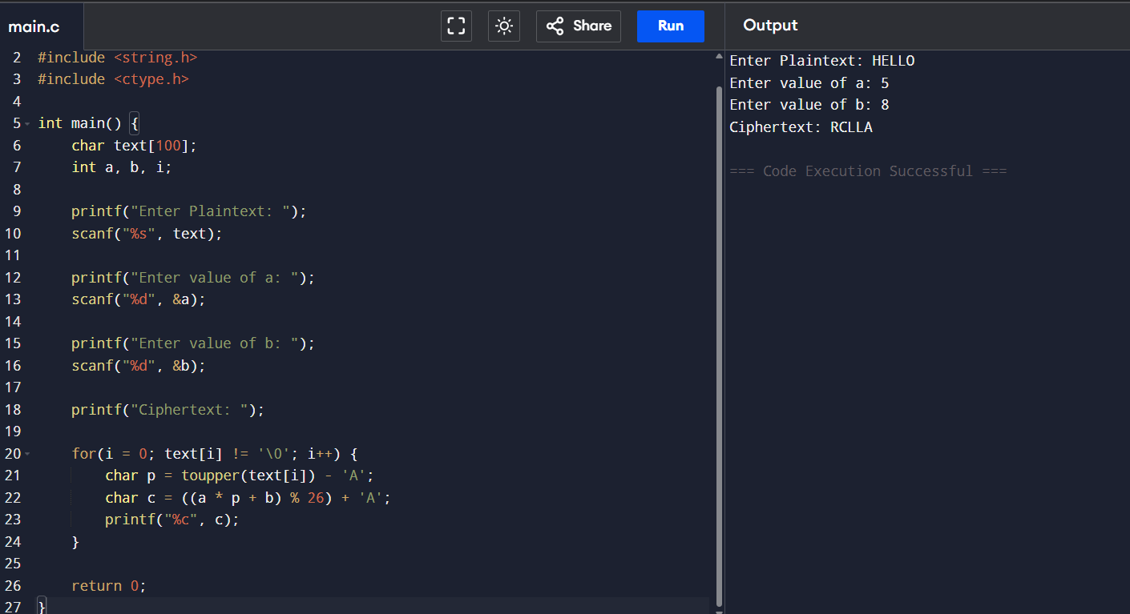

6. Write a C program for ciphertext has been generated with an affine cipher. The most frequent letter of
the ciphertext is “B,” and the second most frequent letter of the ciphertext is “U.”Break this code.
#include <stdio.h>

int modInverse(int a) {
int i;
for(i = 1; i < 26; i++) {
if((a * i) % 26 == 1)
return i;
}
return -1;
}

int main() {
char cipher[100];
int a = 5, b = 7;
int a_inv = modInverse(a);
int i;

printf("Enter Ciphertext: ");
scanf("%s", cipher);

printf("Decrypted Text: ");

for(i = 0; cipher[i] != '\0'; i++) {
int c = cipher[i] - 'A';
int p = (a_inv * ((c - b + 26) % 26)) % 26;
printf("%c", p + 'A');
}

return 0;
}
